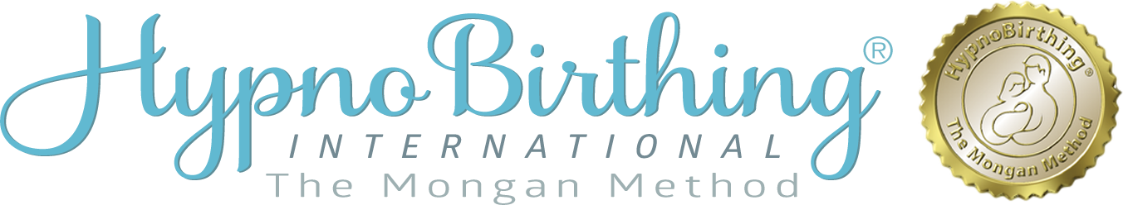

Course Enrollment Form

_____________________________________________________________________________________
Pregnant Person’s Name Please circle your preferred pronoun: She / He / They

_____________________________________________________________________________________
Please circle or fill in your preferred identifying term for use in the birth journey:
mom, dad, birthing person, parent, other______________________________.

_____________________________________________________________________________________ Mailing Address

_________________________________________ Preferred contact phone | _______________________________________ Alternate phone
_________________________________________ Email Contact | _______________________________________ D.O.B
_________________________________________ _______________________________________
Birthing Companion Name Relationship

_______________________________________________________________________________________
“Please circle or fill in your Birthing Companions preferred identifying term for use in the birth journey: mom, dad, birthing companion, parent, other__________.”
__________________________________________ Birthing Assistant Name | _______________________________________ Relationship (doula, friend, etc.)
__________________________________________ Care Provider Name & Title | _______________________________________ City
__________________________________________ Birthing Facility | _______________________________________ City
__________________________________________  Have you birthed before? What baby number is this? | _______________________________________  How did you hear about us?
__________________________________________  When is baby expected? | _______________________________________  How many weeks pregnant will you be when you begin classes?
Do you have any health or obstetric concerns?

I wish to enroll for the 5 Week HypnoBirthing® Course beginning:

Date: Location:

Tuition fee: $350 - (fee includes textbook, audio practice MP3’s, and workbook.)

To secure your place at the course, the non-refundable deposit is required.

Please return your form and confirmation of paid deposit to: becky@nurturedmommy.com

Enrollment Agreement

The HypnoBirthing® Institute may contact you for quality assurance and research purposes. If you consent to be contacted now, please note that you are free to change your mind at any time. Be assured that we will not share your personal identifying information with anyone outside the HypnoBirthing® Institute for any purpose. Thank you for your help in collecting data to support the growth of HypnoBirthing ®.

I do I do not agree to be contacted by the HypnoBirthing® Institute.

I hereby state that I am enrolling in the HypnoBirthing® class of my own free will and with the understanding that this is a program designed to teach me to use my own natural abilities to bring my mind and my body into a state of relaxation. I further understand that the content of these classes is in no way intended to be represented as medical advice nor as a prescription for medical procedure. I am aware that I should seek the advice of a health-care provider to answer any health-related or pregnancy-related issues surrounding my pregnancy, my labor, or my birth.

I therefore agree that I will in no way hold the instructor of the HypnoBirthing® classes, or the HypnoBirthing Institute®, its owner, or its representatives responsible for any special circumstances that could arise as a result of my pregnancy, my labor, or the birth of my child; and I agree that neither I nor any member of my family will make any claim or initiate any suit against any of the above-named parties now or at any time in the future.

Pregnant Person’s Signature Date

